&
COACHING
WE OFFER
&
STRATEGY CONSULTING
Looking to scale? Needing to redesign your
organization or team? Culture design?
CONSULTING
We leverage our experience and expertise to
assess your challenge and create
customized solution that aligns with your
strategy and goals
a
CONTACT
US
COACHING
New leader? Encountering change resistance?
Performance issues? Professionally stuck?
803-386-8861
We offer executive and team coaching
approaches to help maximize your skills and
that of your team.
info@thenatalieparker.com
FACILITATION AND TRAINING
Offsite? Strategy Session? Team building?
We are known for our ability to create deep
memorable learning experiences that will
impact you and your workforce.
201 Tom Hall #855
Fort Mill, South
Carolina 29715
We co-create unique experiences that ensure
you meet your goals and get results.
www.thenatalieparker.com
ACCELERATE GROWTH WITH US!
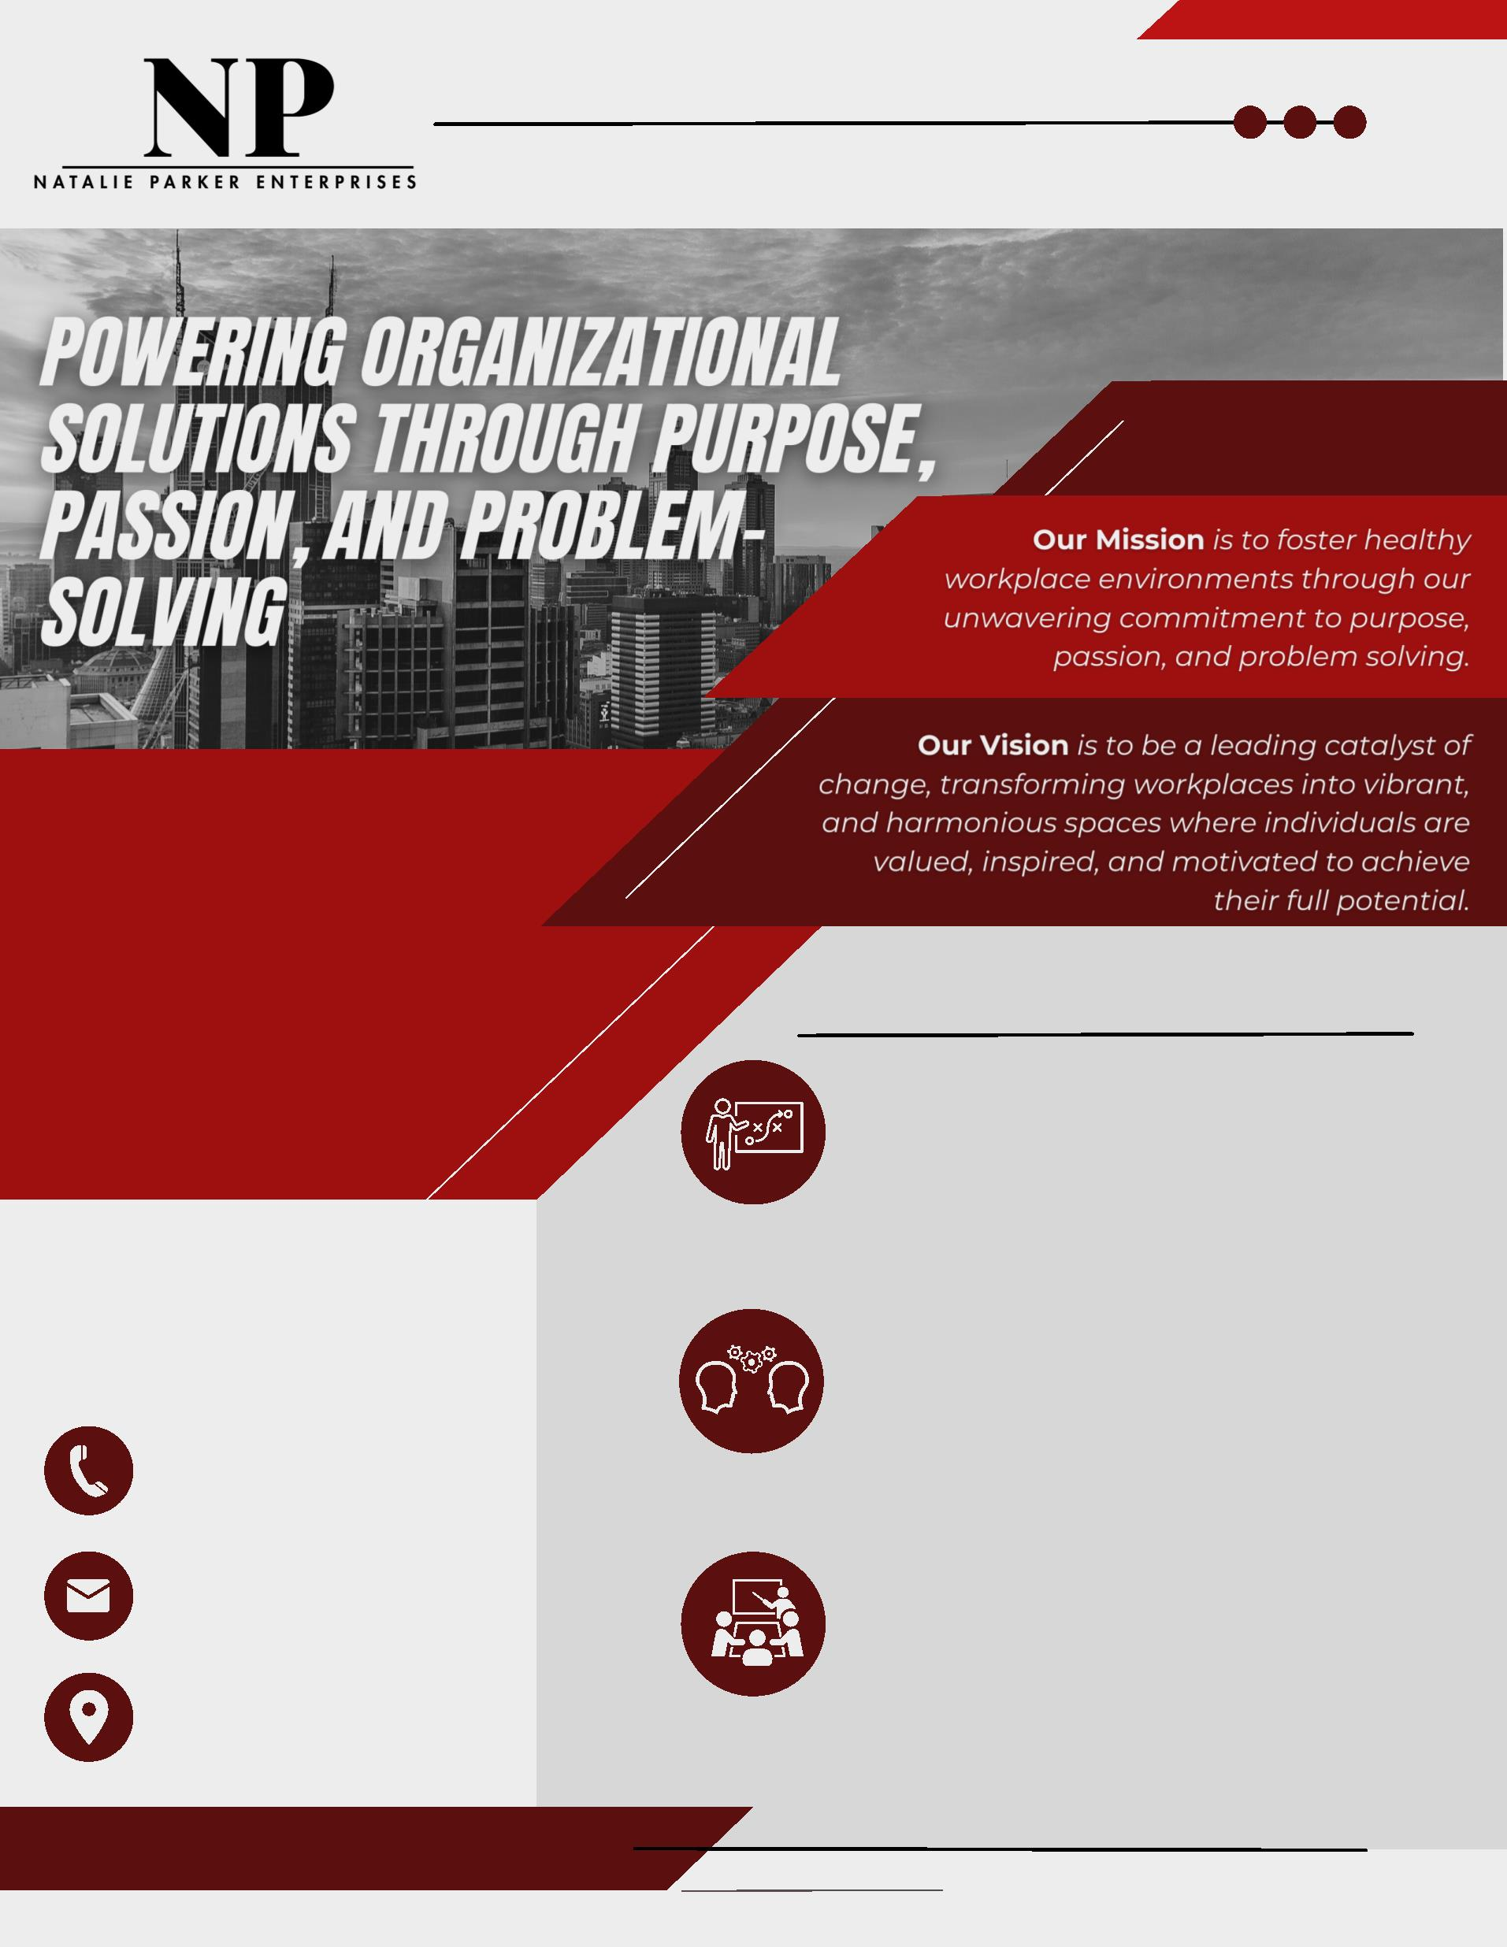

Organizational Development Strategist
Talent Multiplier, Executive Coach
and Human Resource Practitioner
Biography
Natalie Renee Parker is regarded as a champion of organizational health. She draws from her skills as both a master facilitator and certified coach to
diagnose, build strategy, and drive teams to own their improvement initiatives. Natalie believes that the job of a consultant, facilitator, or coach is not
to provide an answer, but to use challenging and supportive leadership to lead the client to confront opportunities with values-based authenticity; by
knowing oneself, clients can best recognize the answers within themselves to unearth the solutions to their challenges. Her ability to quickly garner
trust, allows her to get to the heart of key issues and bring opposing views to the table to help the team or organization grow. Understanding that
there is no “one-size-fits-all” approach for organizational interventions, Natalie balances her experience and intuition to create a solution. One key to
her success is her ability to unearth unspoken issues through authentic communication and mutual accountability. Her experience in lean
manufacturing allows her to guide teams to solutions with a system thinking approach that makes long-lasting positive business impact.
Natalie has extensive experience developing executives, leaders, and employees, aligning their career goals with organizational strategy and objectives.
She is a natural problem solver that focuses on conflict management and critical thinking. She has led the creation of talent strategies that focus on
high-potential and high-performing employee development. Natalie believes that talent should be strategic and thoughtful. She believes in
communication and consulting to understand the needs and goals before implementing solutions. She has designed enterprise-wide efforts for
succession planning, employee coaching, conflict resolution conversations, and accountability management.
A native of South Jersey, Natalie now resides in the greater Charlotte region with her husband and two children. Outside of her vocation, Natalie
serves as a faith leader in her church. Additionally, Natalie serves as Secretary on the Board of Trustees at Bennett College as a member of the
Executive Leadership Team accountable for Governance.
Experiences and Certifications
Extensive track record of developing talent management systems that accelerate talent readiness and increase pipeline of “ready-now” talent.
Design Content and Facilitate Leadership offsites | Development Programs, Training, and Interventions | Korn Ferry Leadership Assessment
Board Member leading governance, knowledge management, policy, and culture | George Mason Leadership Coaching Certification
Lockheed Martin Executive Coaching Certification | Crucial Conversations & Crucial Accountability (Vital Smarts)
Facilitation and Targeted Selection, Development Dimensions International (DDI) | Lockheed Martin-LM21 Black Belt
Talent Management Certification, University of North Carolina | DiSC Behavior Assessment | Strategic Organization/Accountability Leadership
info@thenatalieparker.com
